**Assignment Day 5**

Q1. Add a 10GB disk to the CentOS.

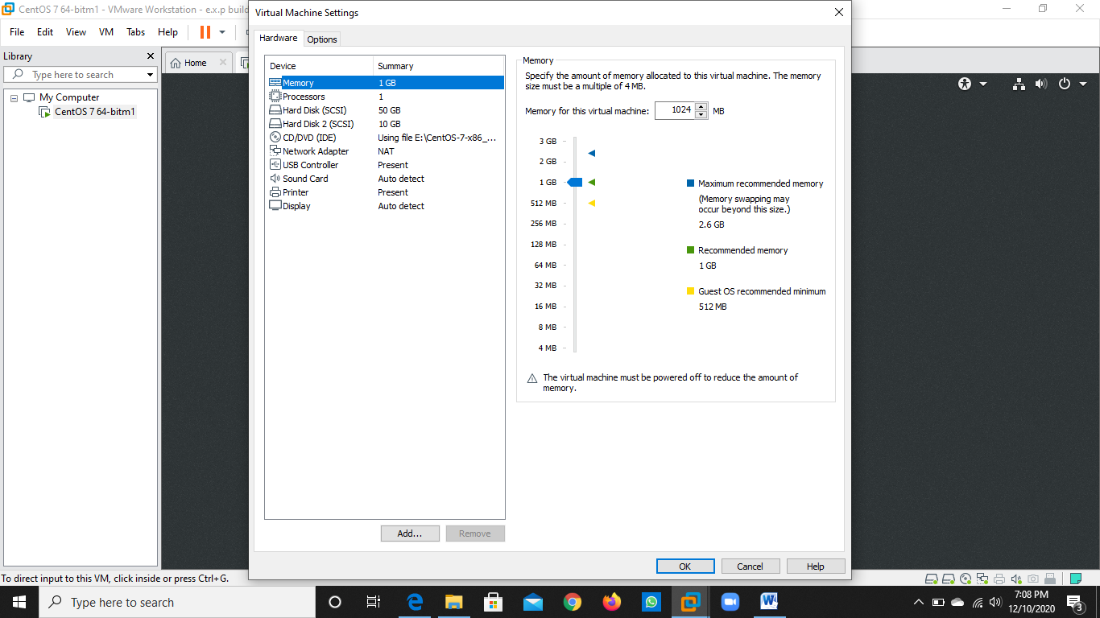

Q2. Create 2 Partitions 4GB and 6GB of Space respectively

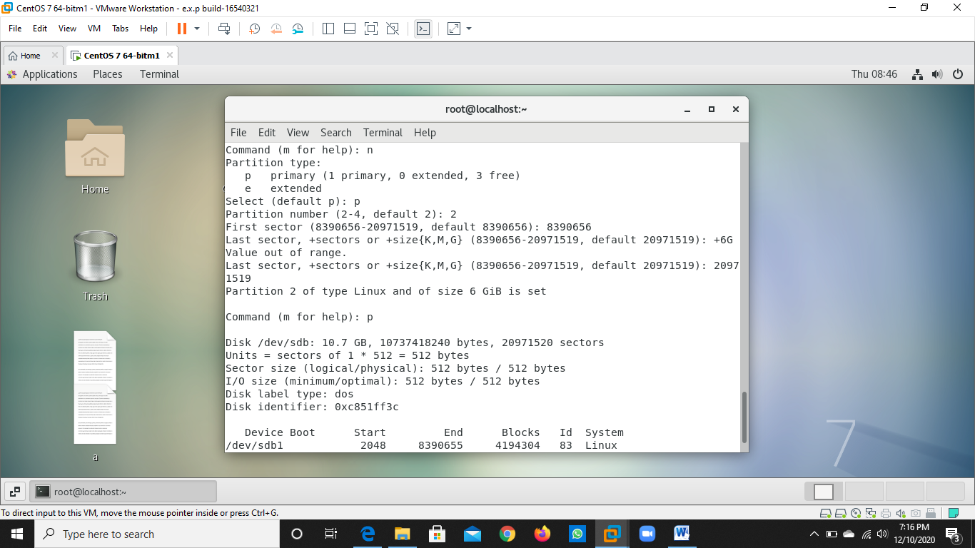.

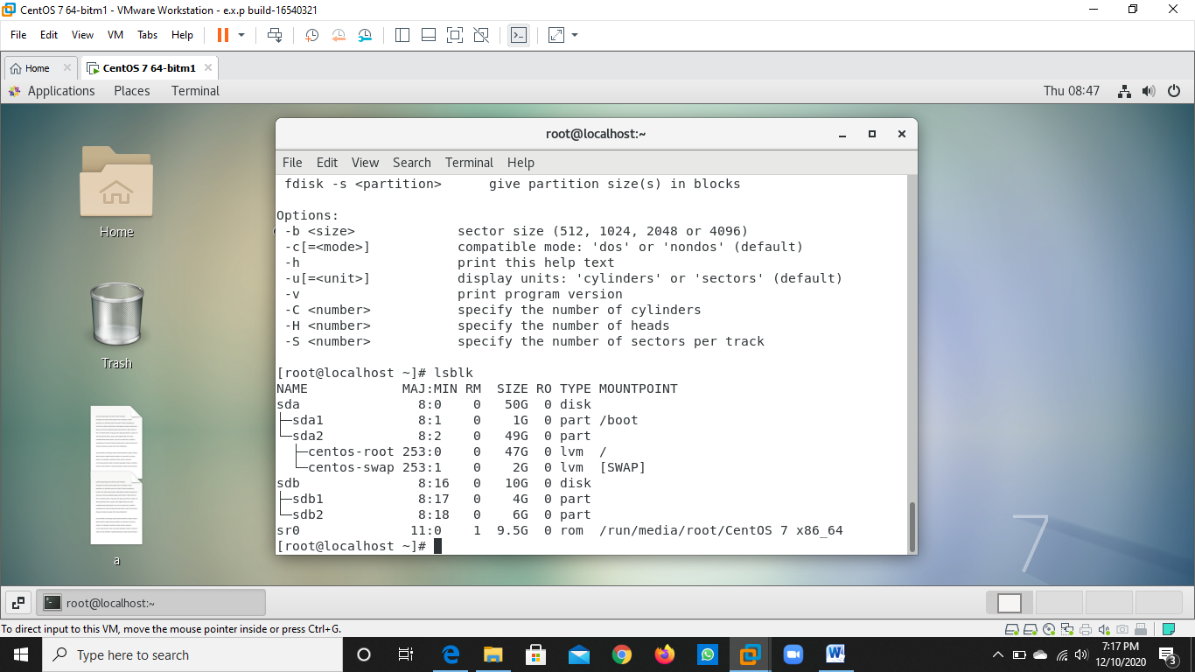

Q 3. Format 4GB with xfs and 6GB with ext4 file system.

Note . xfs not supporting

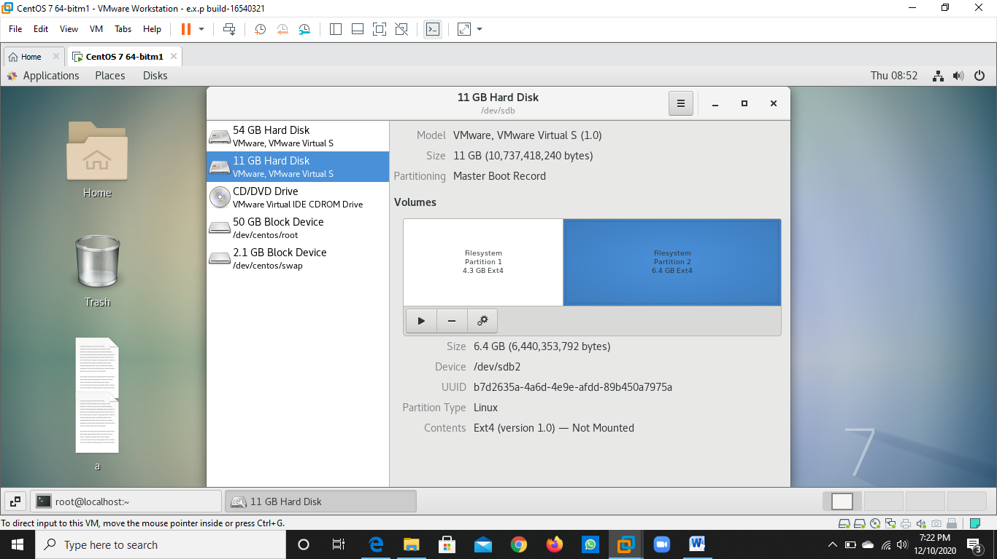



Q4. Mount 4GB and 6GB in /data and /music directory respectively.

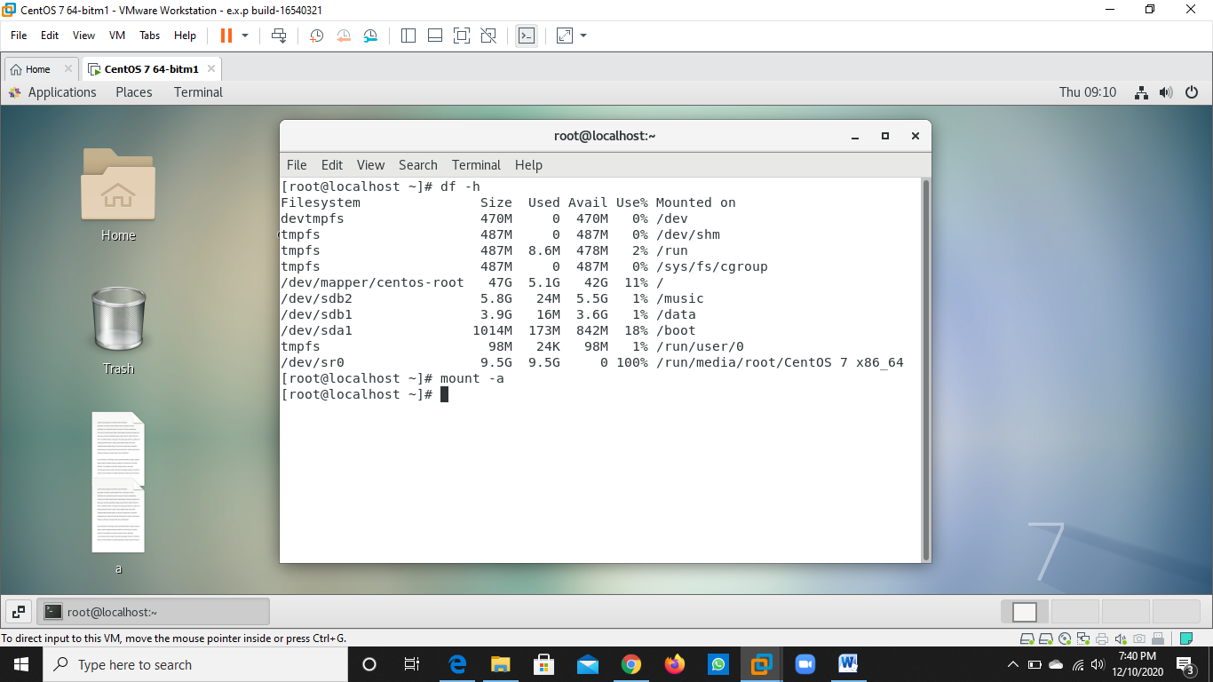

Q5. Create one file of 1GB in each of the mount point created above.

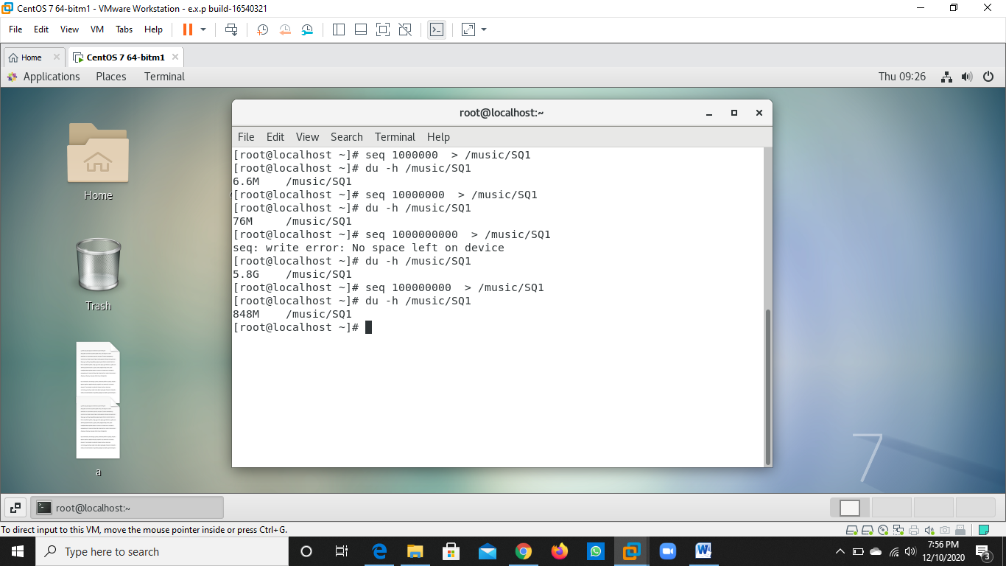



Q6. Verify the disk Consumption and disk space free in the mounted partitions

